|  |
| --- |
| STREET FOOD KHANA  [The yummy store for your Hungry Stomach..] |

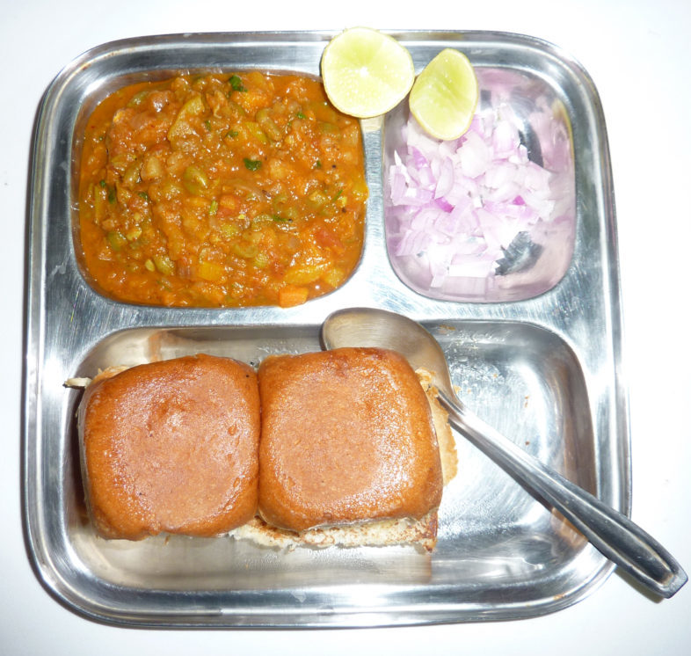

Overview:

Street Food Khana application is an eCommerce store that sells various Street Foods for your hungry stomach in online either through Mobile App or Web Interface.

In our application we will have mainly Customer, Clerk/Assistant, Cook/Chef, Delivery Boy/Agent and Admin with respective activities that needs to be addressed with as follows:-

* Customer
  + Customer should be able to perform following activities in the application:
    - Registration
    - Login
    - Search for Street Food
      * Searching based on Geo-Location radius of 5m-10m only.
    - Search for Street Food Vendor(s)
      * Searching based on Geo-Location radius of 5m-10m only.
    - Browse Street Food Menu(s)
      * Browse based on Current Day’s Menu which is uploaded to the application previously.
      * Browse based on Street Food Vendor(First Name/Phone Number/Email Address/Physical Address)
    - Order Street Food
      * Order for Street Food
      * Track the Order Status
    - Pay The Order
      * Pay to delivery boy [COD -- Cash On Delivery]
      * Go & Pick-Up [Payment can be made to Street Food Vendor directly]
* Clerk/Assistant
  + Register as Clerk in application
    - Register with Aadhaar Card
    - Register with Voter Card
  + Login
  + Manage Customer(s) orders
  + Inform about new order to Cook
  + Manage cooking status
* Cook/Chef
  + Reads Cook requests from Clerk/Assistant
  + Cooks food

* Delivery Boy
  + Register as Delivery Boy
    - Register with Aadhaar Card
    - Register with Voter Card
  + Login
  + Read Orders
  + Deliver Street Food to customer
  + Take payment from Customer(in cash mode)
* Admin
  + Should Manage Customer(s)
  + Should manage Clerk(s)
  + Should manage Cook(s)
  + Should manage

Application Overall Flow:

This section describes about flow of the application that needs to be addressed with as given in the below diagram

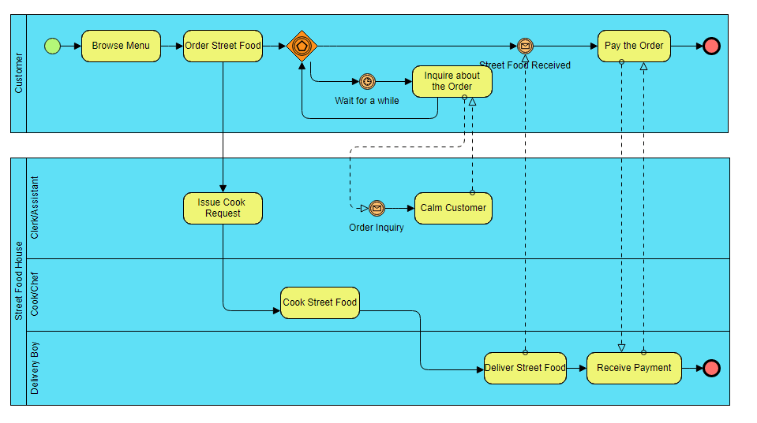

**Geo-Location Currently to be Served with:**

1. SRIKAKULAM, AP, INDIA

**Template(s) to use:**

1. Admin
   1. <https://adminlte.io/>
2. Front-End
   1. Selenia can provide a slim & user-friendly UI if available.
   2. We have provided the reference UI in gmail. Look into it & let us know your thoughts once.